

**PROJECT 3**

**Implementation of Proxy on Ubuntu for Blocking Illegal Websites**

Faculty:

**Mr. Kevin harada, S.Tr.Kom.**

Written By:

**Ahmad Farhan Ibrahim**

**Muhammad Zidan Satrio**

**Pria Adil Laksana Irawan**

Class:

**2ISA3**

**Continuing Education Center for Computing and Information Technology**

**Faculty of Engineering, University of Indonesia**

**2022**

**PROJECT ON**

Implementation of Proxy on Ubuntu for Blocking Illegal Websites

**Developed by**

1. Ahmad Farhan Ibrahim
2. Muhammad Zidan Satrio
3. Pria Adil Laksana Irawan



**Implementation of Proxy on Ubuntu for Blocking Illegal Websites**

Batch Code : 2 ISA 3

Start Date : 26 June 2022  
End Date : 05 July 2022

Name of Faculty : Mr. Kevin Harada, S.Tr.Kom.

Names of Developer :

1. Ahmad Farhan Ibrahim
2. Muhammad Zidan Satrio
3. Pria Adil Laksana Irawan

Date of Submission: 07-07-2022



**CERTIFICATE**

This is to certify that this report titled “Implementation of Proxy on Ubuntu for Blocking Illegal Websites” embodies the original work done by Ahmad Farhan Ibrahim, Muhammad Zidan Satrio, and Pria Adil Laksana Irawan.Project in partial fulfillment of their course requirement at NIIT.

Coordinator,

**Kevin Harada, S.Tr.Kom.**



**ACKNOWLEDGEMENT**



First let us give prays to God who give guidance to us untill we gain complete our Project, entitled “Implementation of Proxy on Ubuntu for Blocking Illegal Websites”

As we write this article, we get a lot of support from various parties. Among others :

1. Our parents, who always help in the form of spirit and material.
2. Kevin Harada, S.Tr.Kom. as faculty of CCIT Faculty of Engineering, University of Indonesia.
3. Our friends who always give the information that they know, exchange ideas and give encouragement to us in writing this article.

We know that the result of our article is far from perfect and there are still many shortcomings, we hope readers will give comments and suggestions in building this article in order to become better. We hope this article can be useful for those who read or hear, especially for CCIT students of the Faculty of Engineering UI.

Best Regards,

**Author**

**System Summary**:

Object Oriented programming is a programming style that is associated with the concept of Class, Objects and various other concepts revolving around these two, like Inheritance, Polymorphism, Abstraction, Encapsulation etc.

In this paper the writer will discuss about "Book Store App as an Implementation of C++" the author will discuss in this project about programming Application In Bookstore which contains Class, if else, goto function, switch case and transient function.

In this project, we aim to make it easier for all the work in the bookstore. So, we can help customer to see and search for Title, Author,and Price of the book that customer wants to buy easily and then we can process book purchases that will be made by customers.

**SYSTEM ANALYSIS**

1. First, open the terminal on Ubuntu Linux, then type “sudo su” to enter root level, before we start configure our proxy we must installing squid 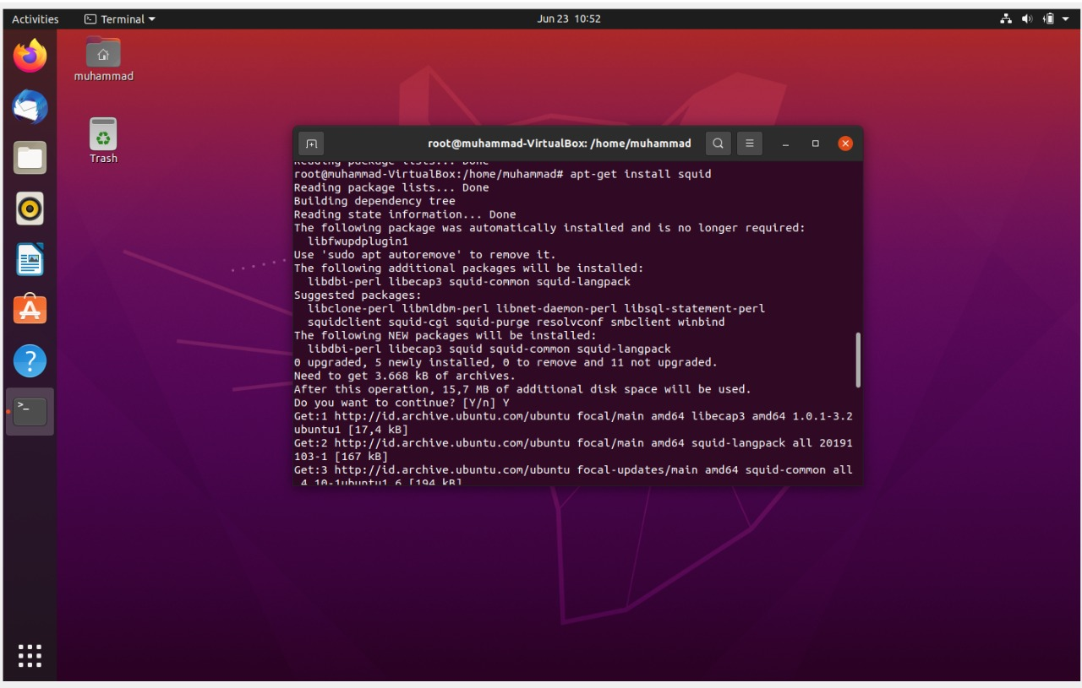
2. After we installing squid, then for configuring squid, we must input “gedit squid.conf”

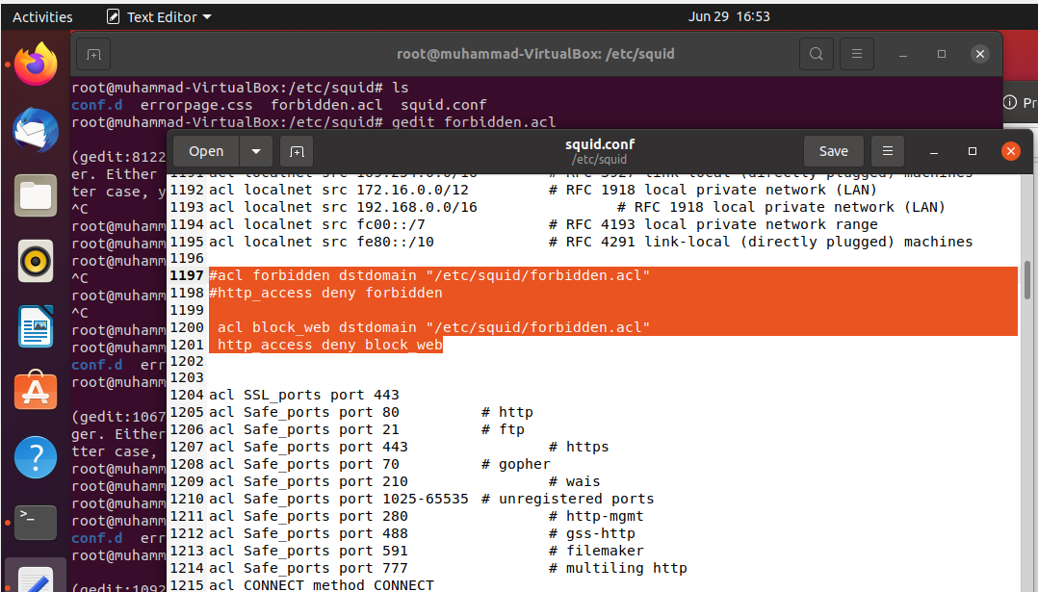

**CONFIGURE**

3. After we configuring squid, then change direction to /etc/squid/forbidden.ac and open it, in

here we input the list of All website that we want to block it.

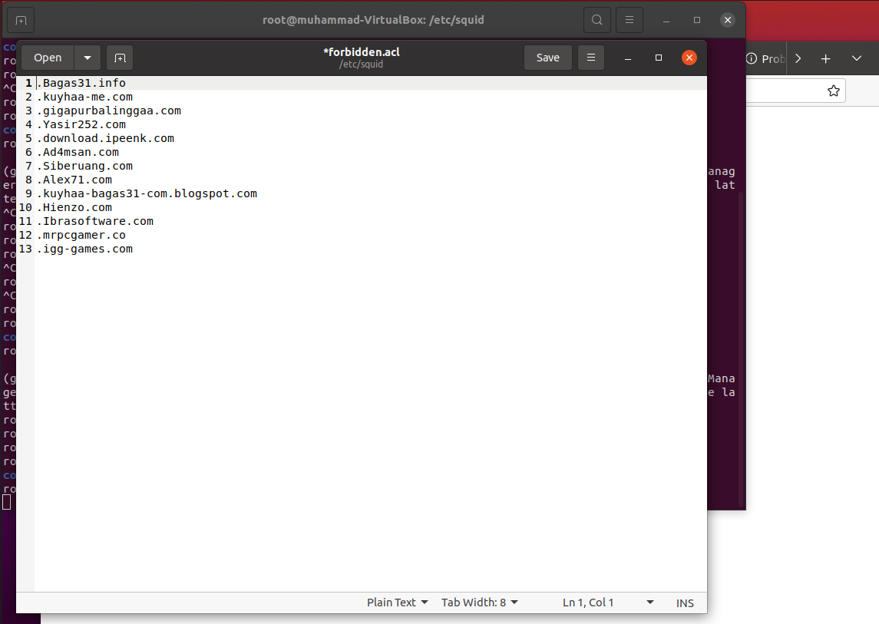

4. Next, we must setting the proxy setup on PC client

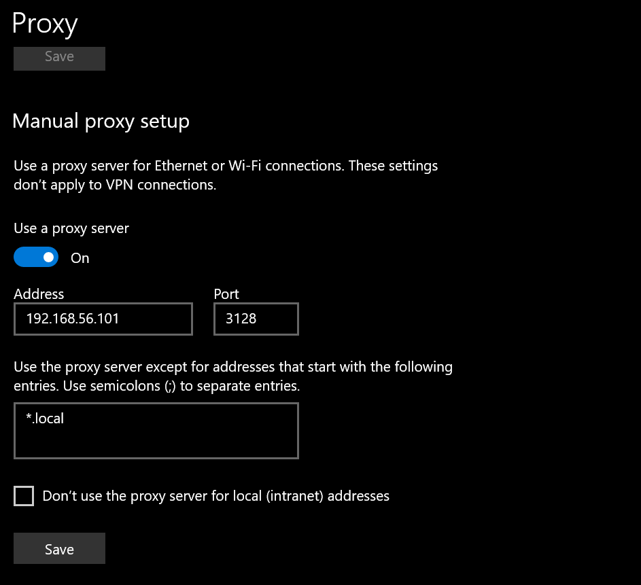

5. After we setting the proxy setup on PC client, we must setting our proxy too on virtual

Machine, then we open the firefox on ubuntu and go to setting on firefox then we search proxy

and go to connection settings then we choose manual proxy configuration to configurating the

proxy.

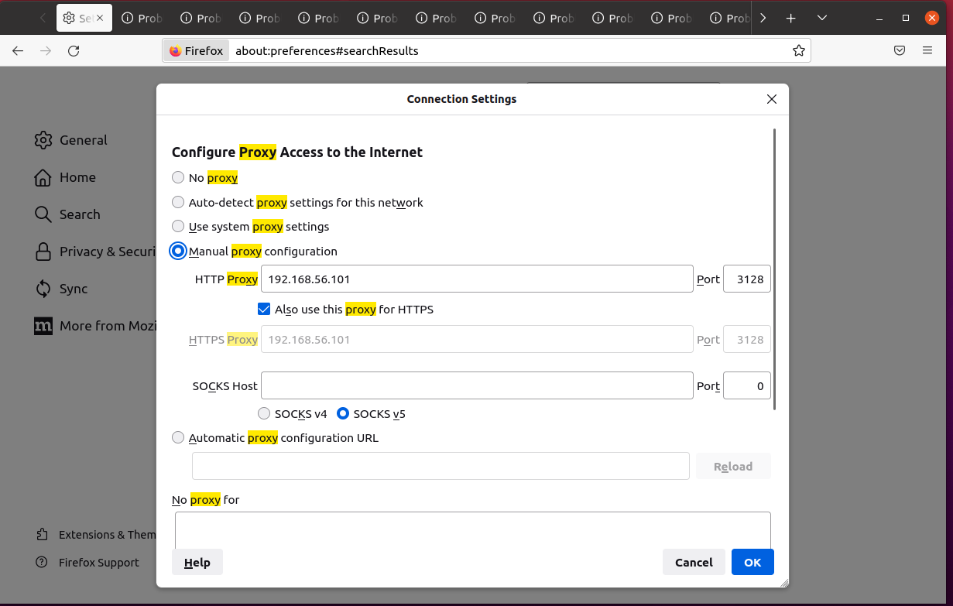

6. Then, we open the website that we have blocked.

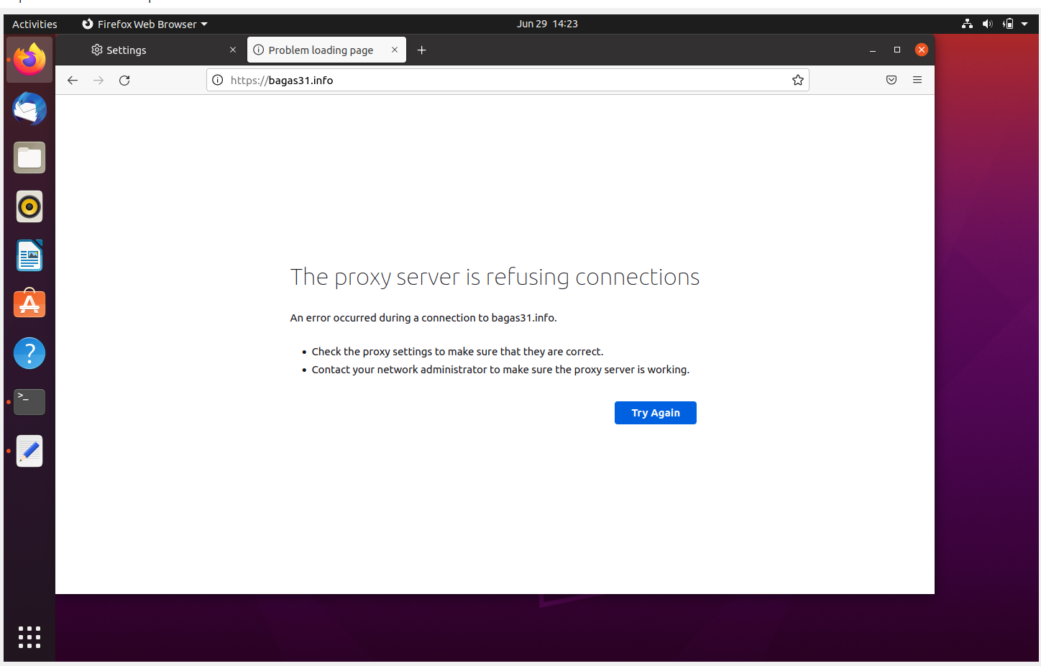

7. Then, we can check all the website that we have blocked, and then we can see that the

website have finished to block.

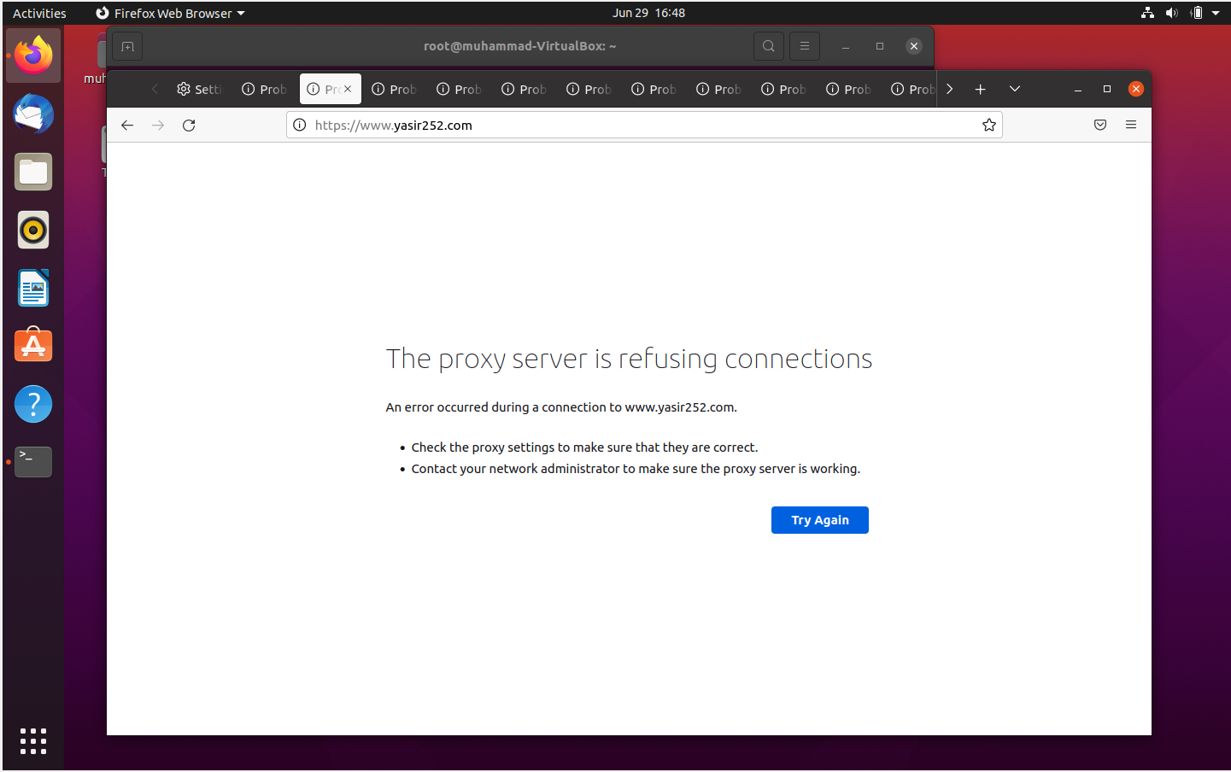

8. And the last, we must testing all the website that we have blocked on PC client in

Other network.

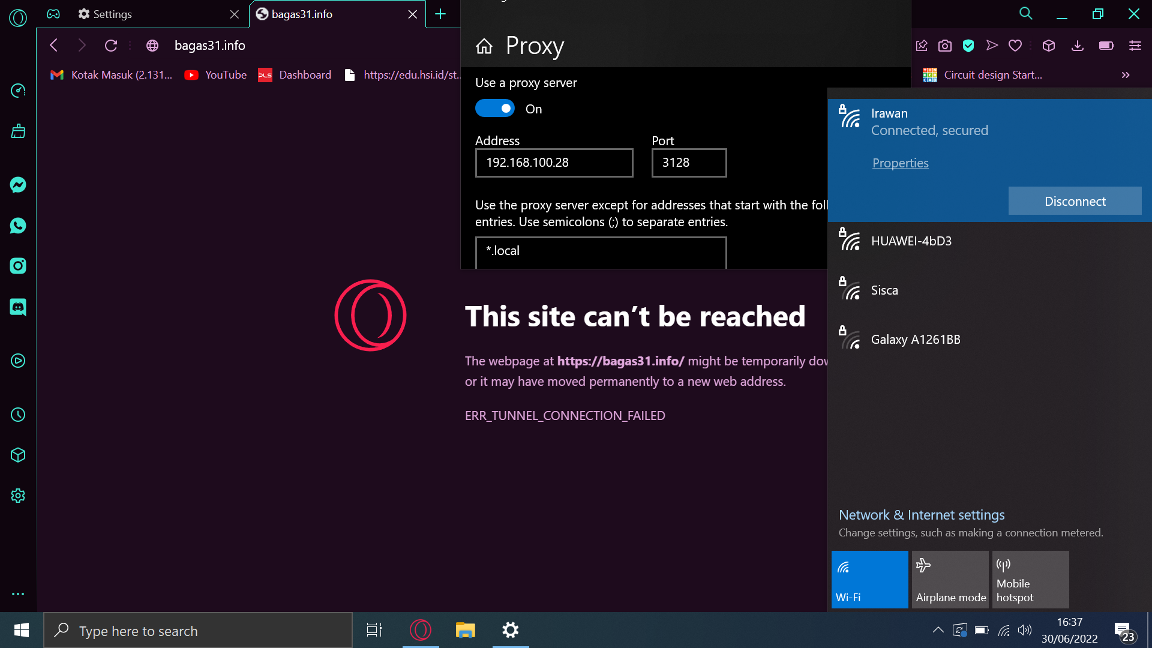

**CONFIGURATION**

**Hardware : AMD RYZEN 5, RAM 16 GB, SSD 512 GB**

**Operating System : Windows 10 and Ubuntu Linux**

**Software : Virtual Box Machine**

|  |  |  |
| --- | --- | --- |
| **PROJECT FILE DETAILS** | | |
| **S.No** | **File Name** | **Remarks** |